**Day 1 :**

**Topic**:Account creation and logging in

**Milestone / Activities**:creating salesforce developer org to get started,account activation and login to salesforce account

**Detailed Description:** To create a salesforce developer we have to give all the details like name,company ,role and username etc, and clock sign me up

**Screenshot the Milestone / Activities** :

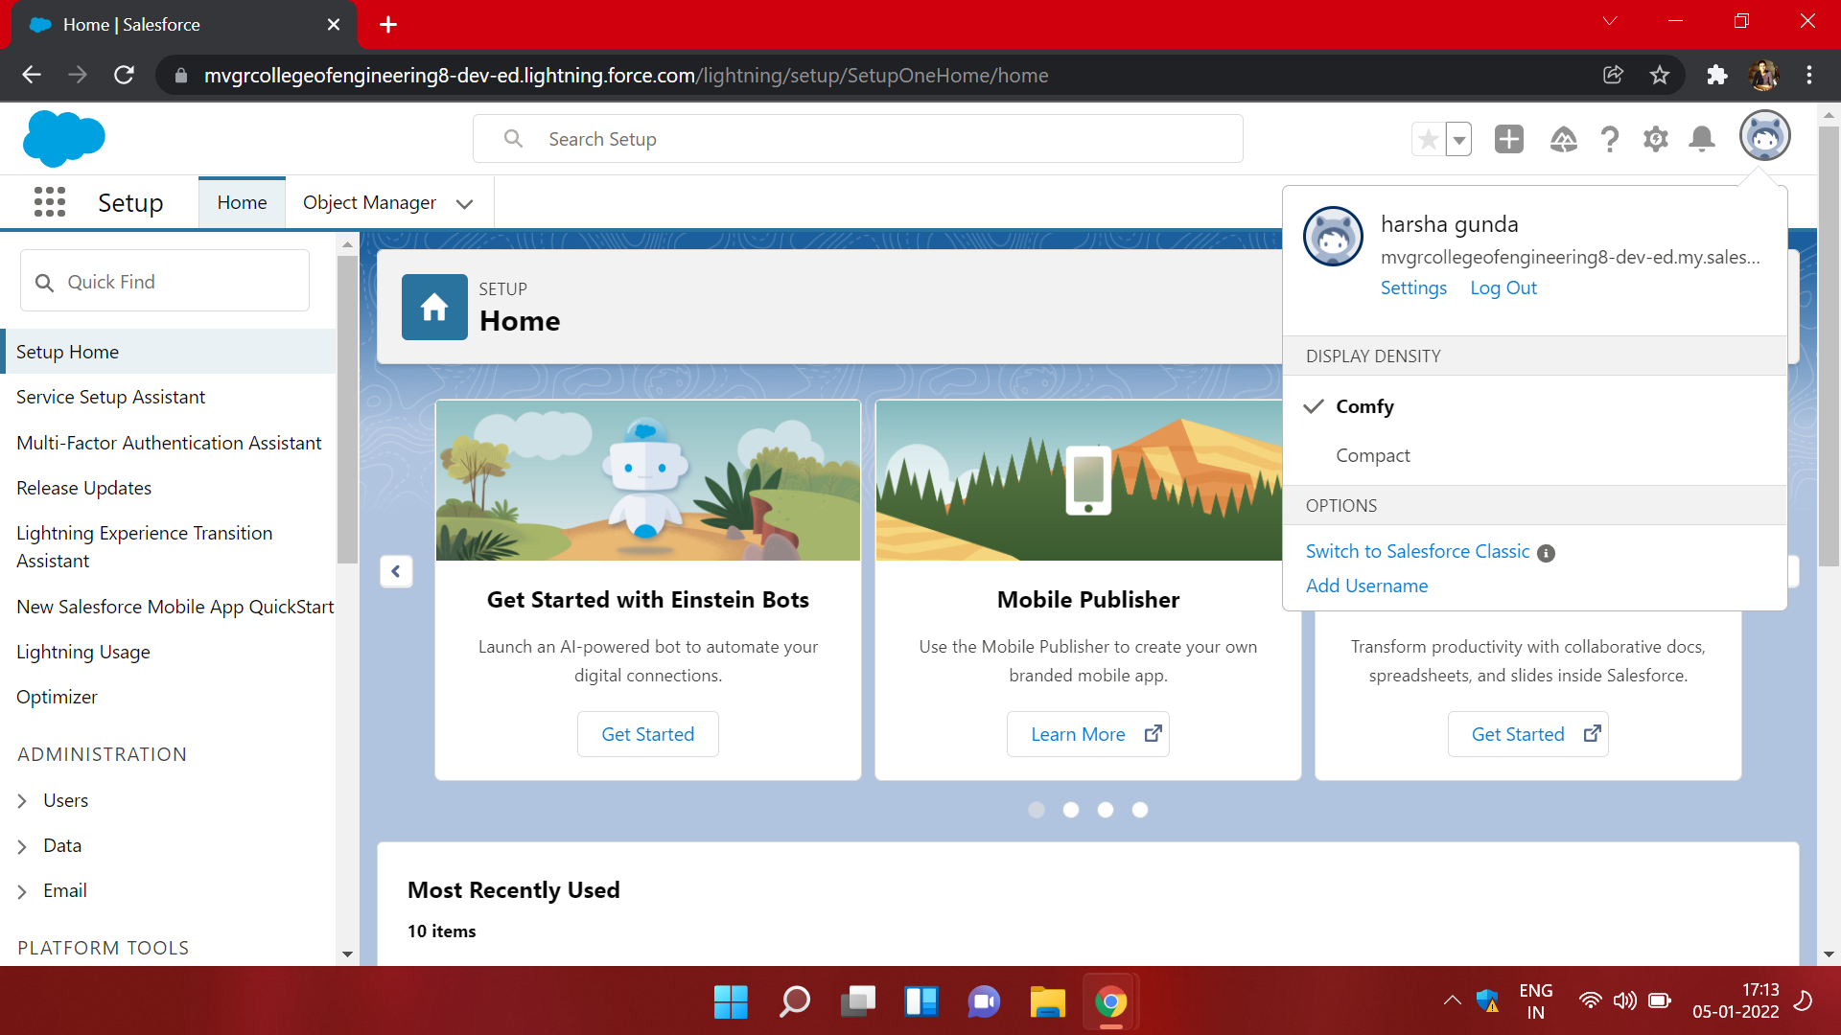

**Day 2 :**

**Topic:**custom object creation

**Milestone / Activities**:creating custom objects for college management application

**Detailed Description:** the custom objects needed for the college management application are college,application form,student,subject.

The college object contains the fields like record info of datatype text ,college fees of datatype currency ,hostel fees of datatype currency ,college name of datatype text ,email of datatype picklist ,capacity of students of datatype picklist.

The application form object form contains fields like college form Id,college fees,hostel fees,guardian name,date of birth ,email, ready to join ,student name etc

The student object contains fields like student name ,address ,application form ,college name ,guardian name ,phone.

The subject object has the fields subject Id of datatype auto number ,paper1 of datatype picklist ,paper2 of datatype picklist,student of datatype lookup(student object)

**Screenshot the Milestone / Activities** :

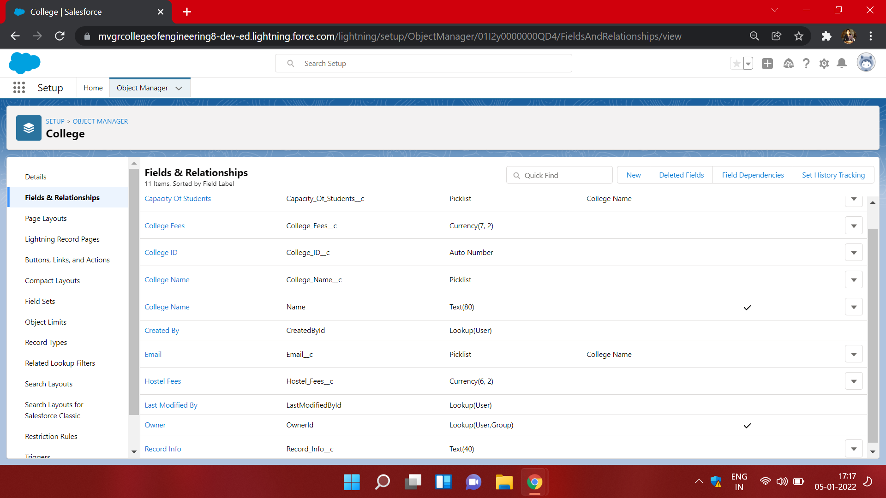

1) Creation of student object

Adding of fields and relations.

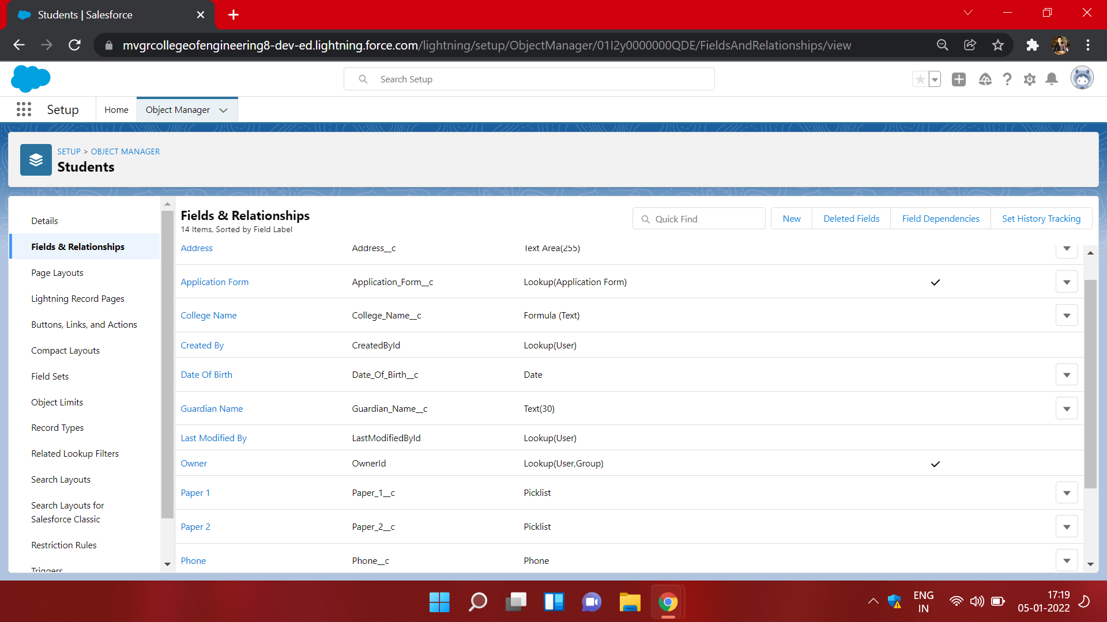

2) Creation of Application form object and

Adding Fields and Relations.

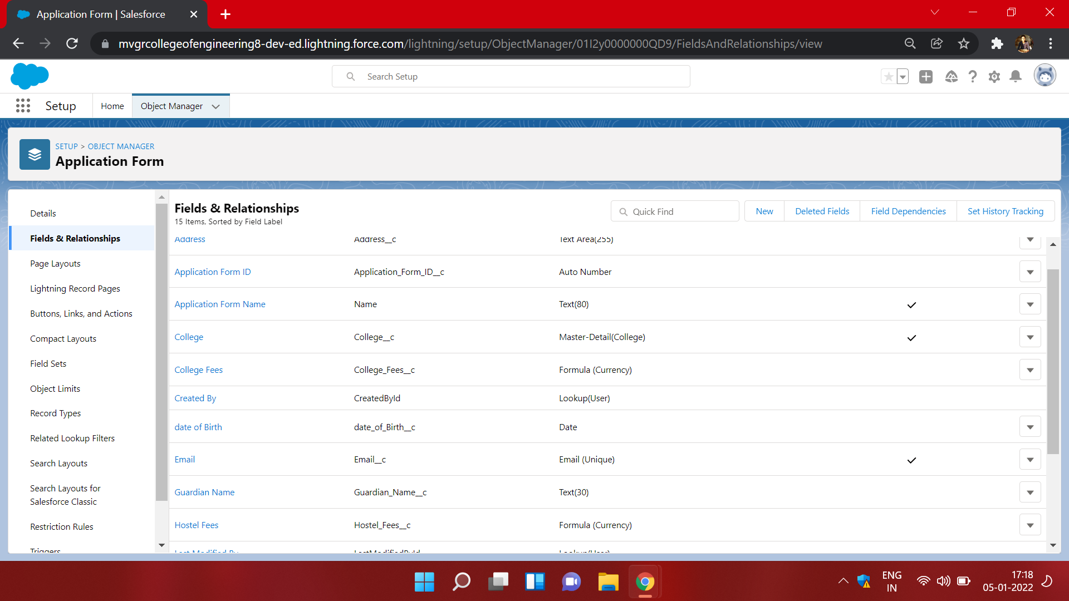

3) Creation of subject Object and

Adding Fields and relations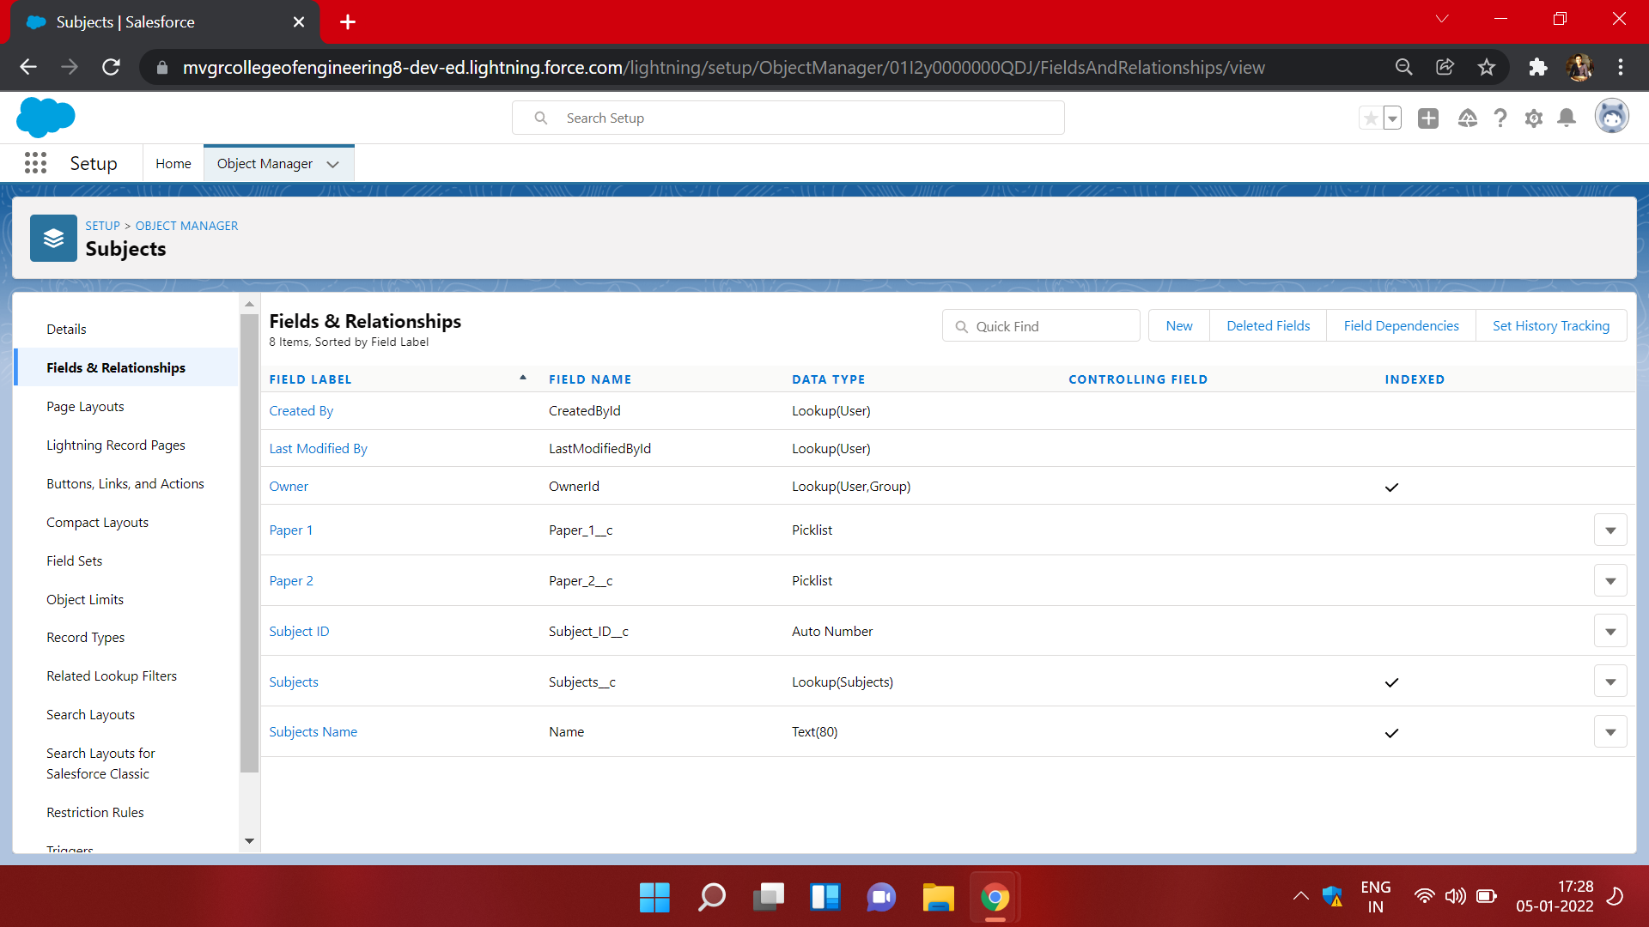

**Day 3 :**

**Topic**:Adding business logic to application.

**Milestone / Activities**:creating global picklists.

**Detailed Description:** The global picklist are the picklists that are available for every field of datatype picklist.when a same picklist have to use many number of times then global picklist comes handy.

Picklist Names:

1)College

2)Paper 1

3)Paper 2

**Screenshot the Milestone / Activities** :

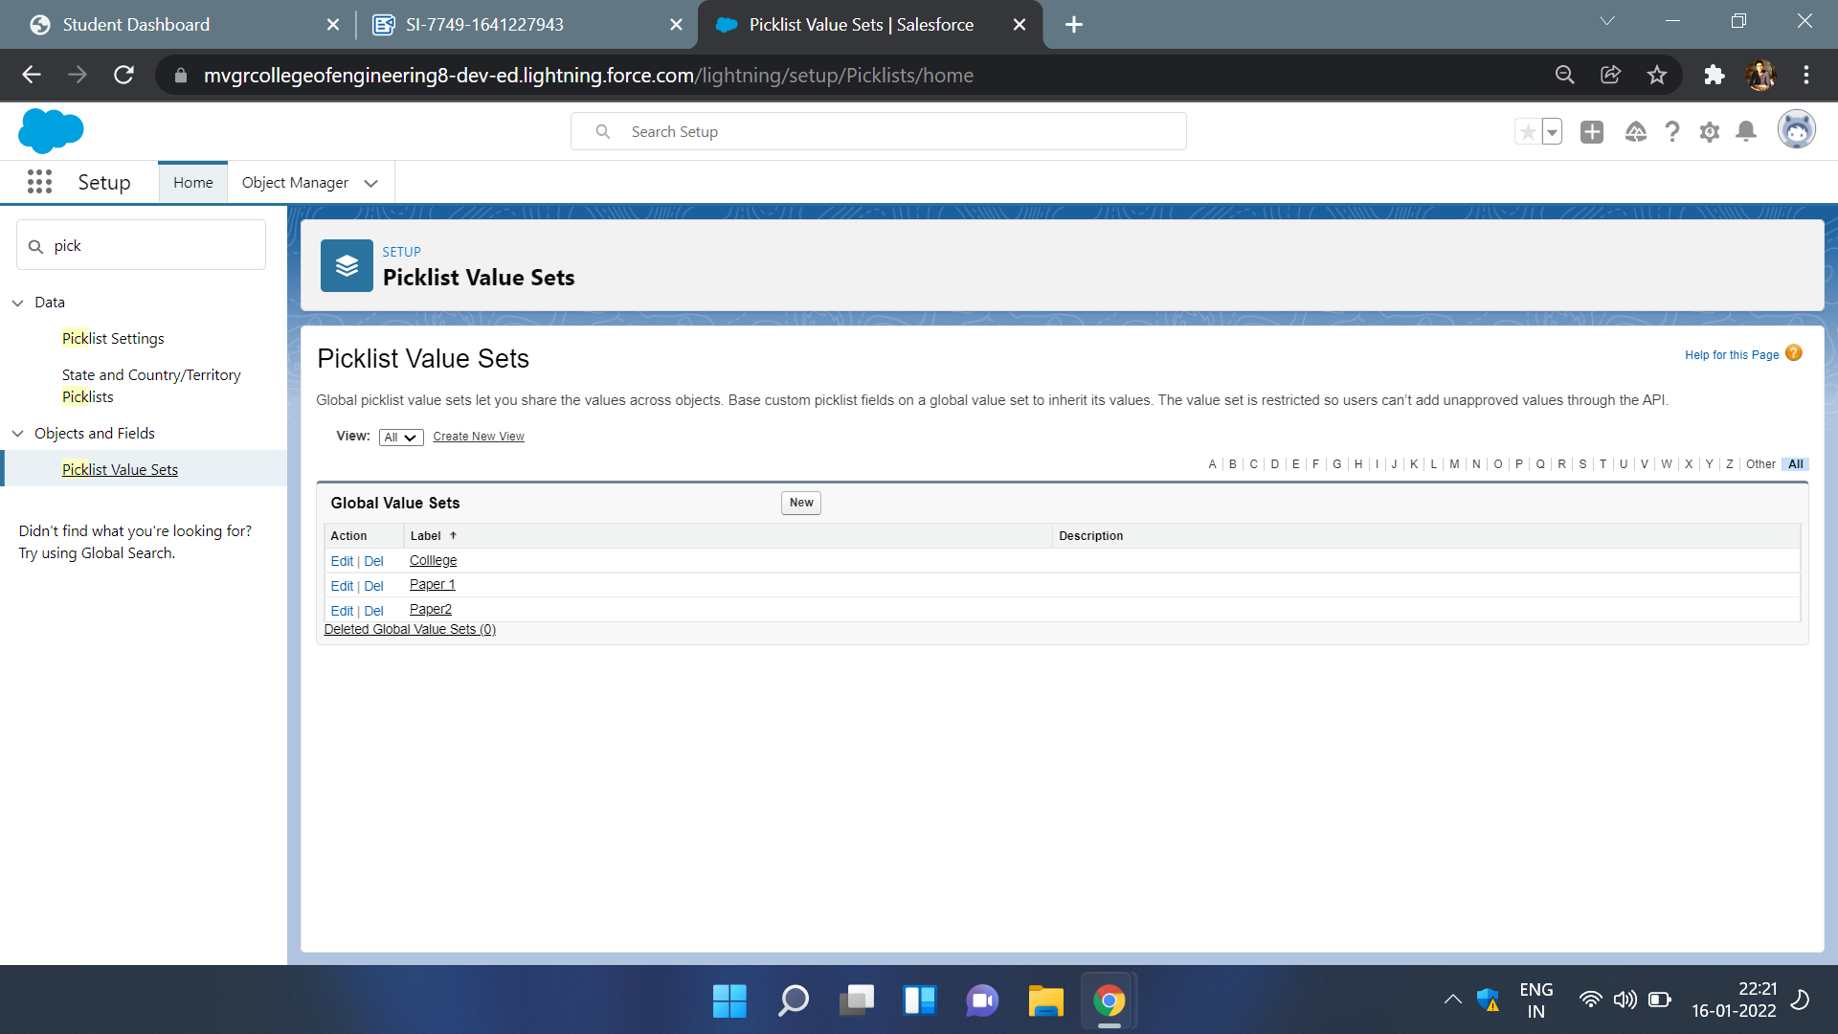

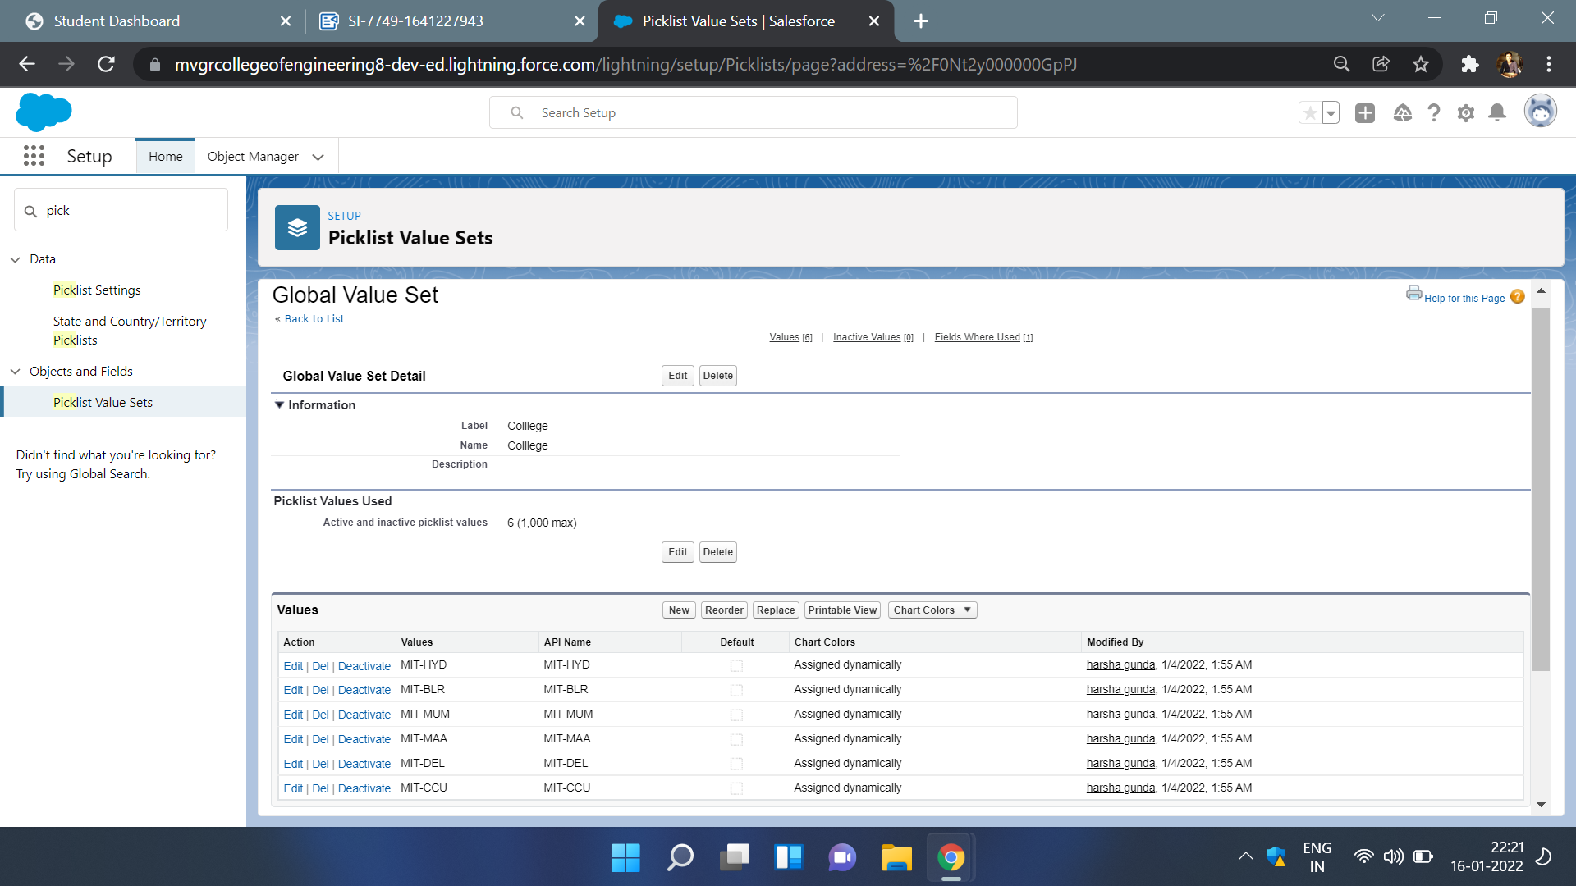

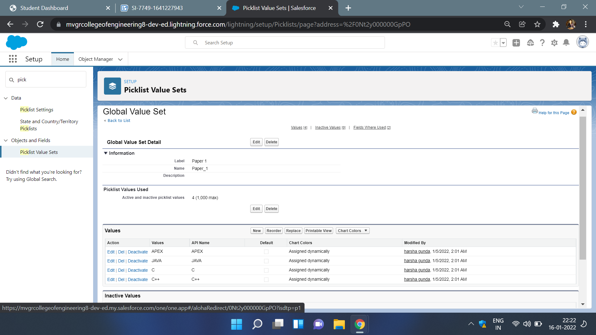

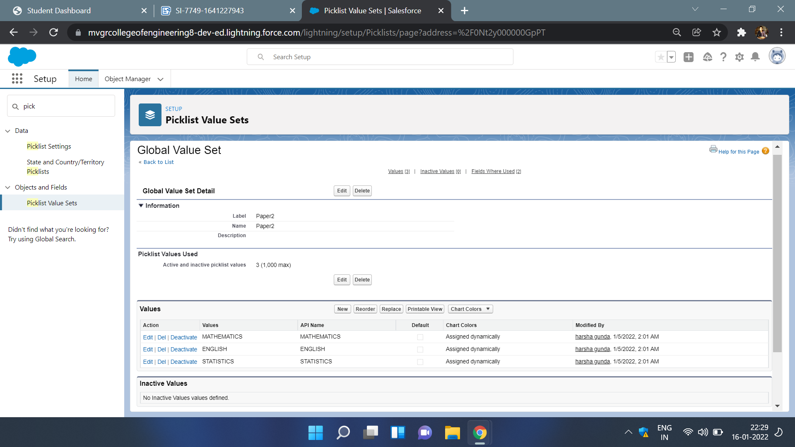

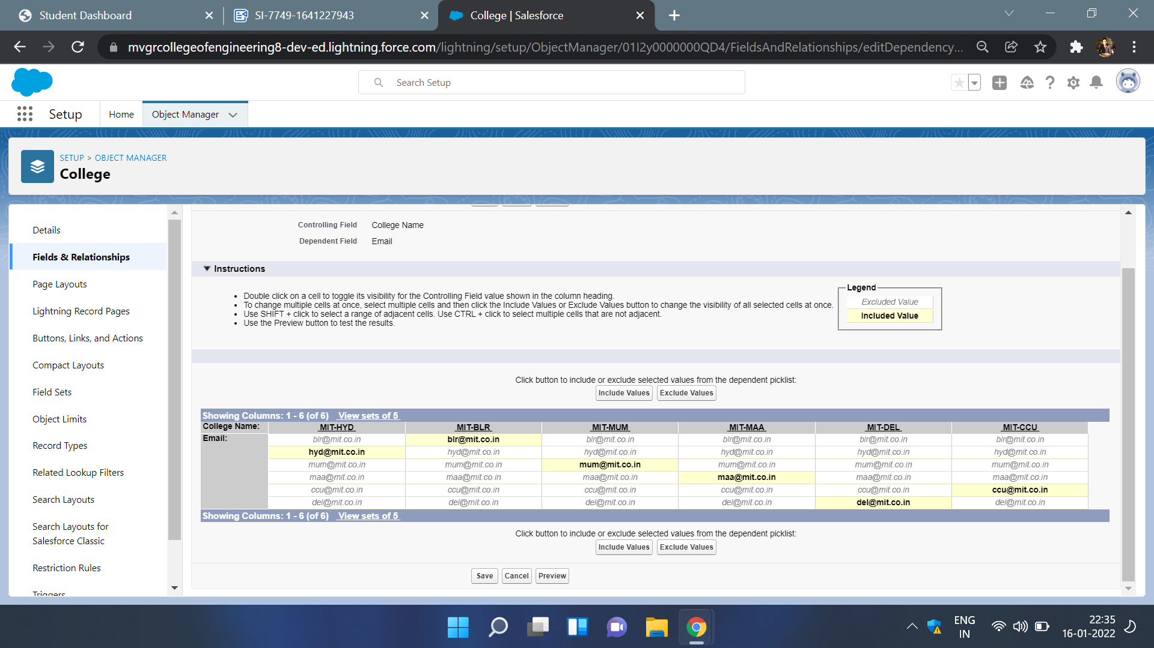

**Day 4 :**

**Topic**:Adding business logic to application.

**Milestone / Activities**:creating field dependencies,and

validation rules.

**Detailed Description:** The global picklist are the picklists that are available for every field of datatype picklist.when a same picklist have to use many number of times then global picklist comes handy.

The validation rules are the rules that are checked when data is entered in the data fields.in the application the validation rule used is the college name of picklist value must be equal to college name of text type.

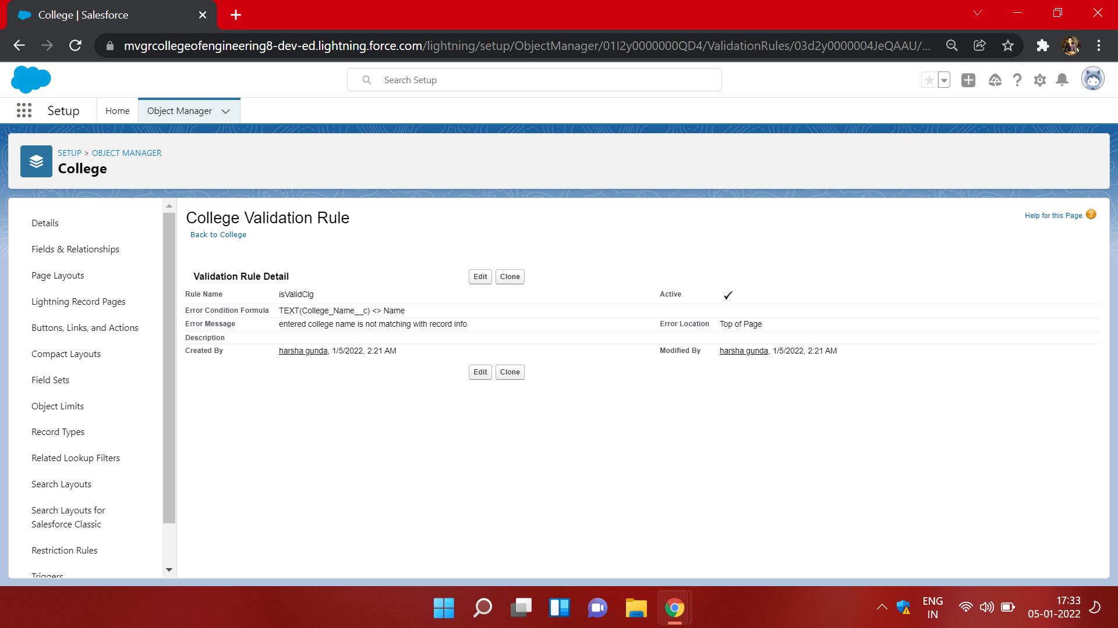

6) creation of field dependencies

college name and email in college object.

college name and capacity of students in college object.

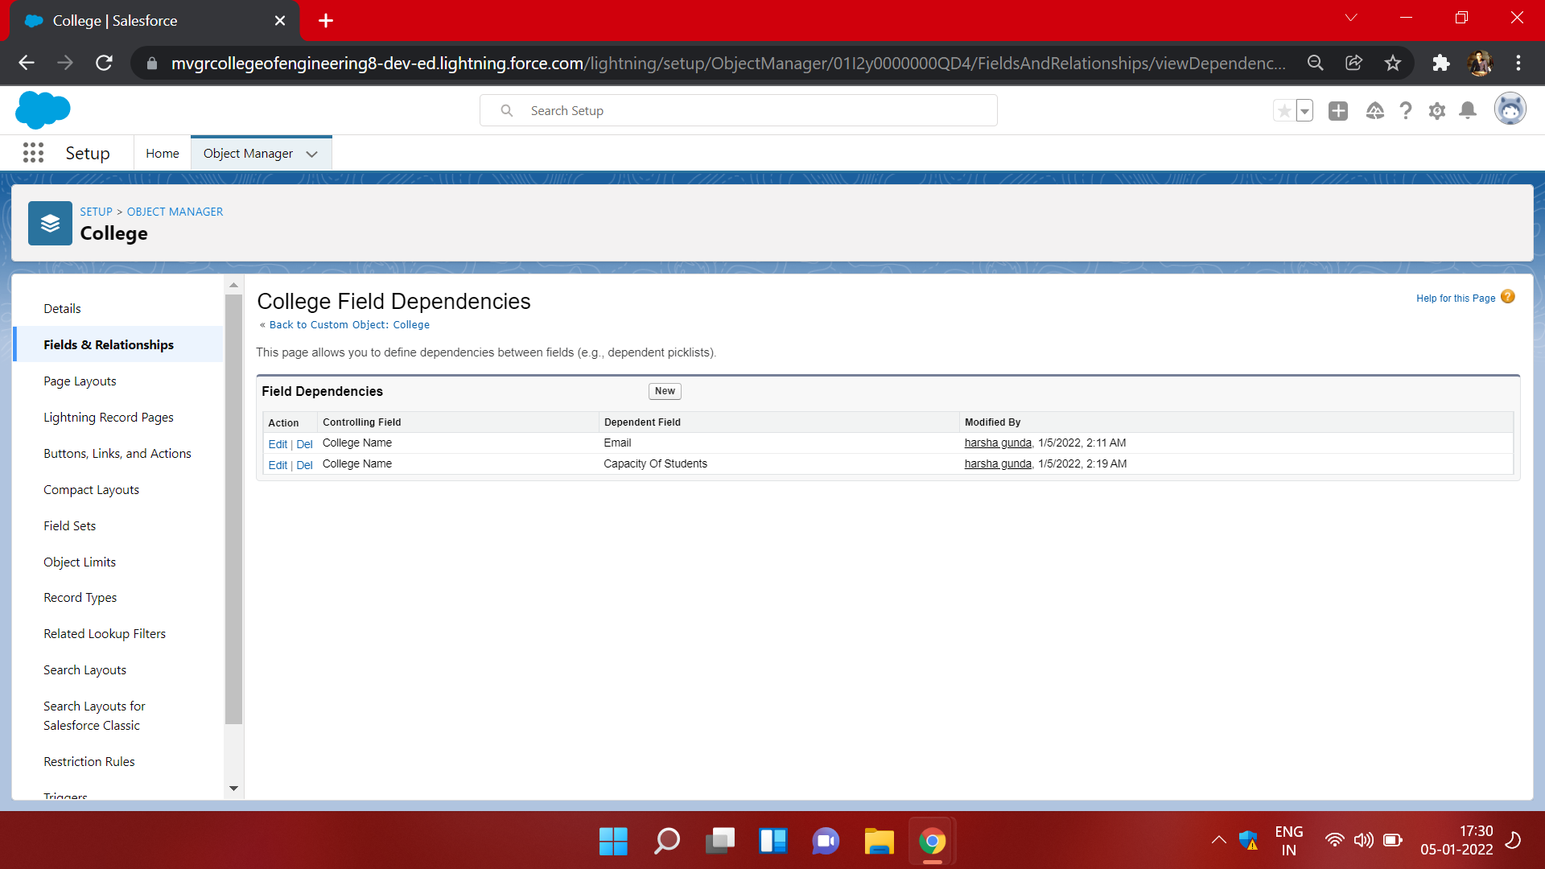

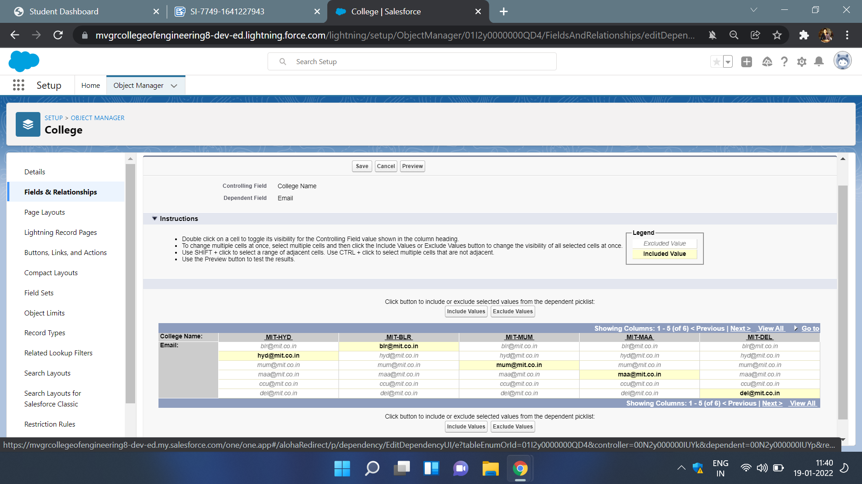

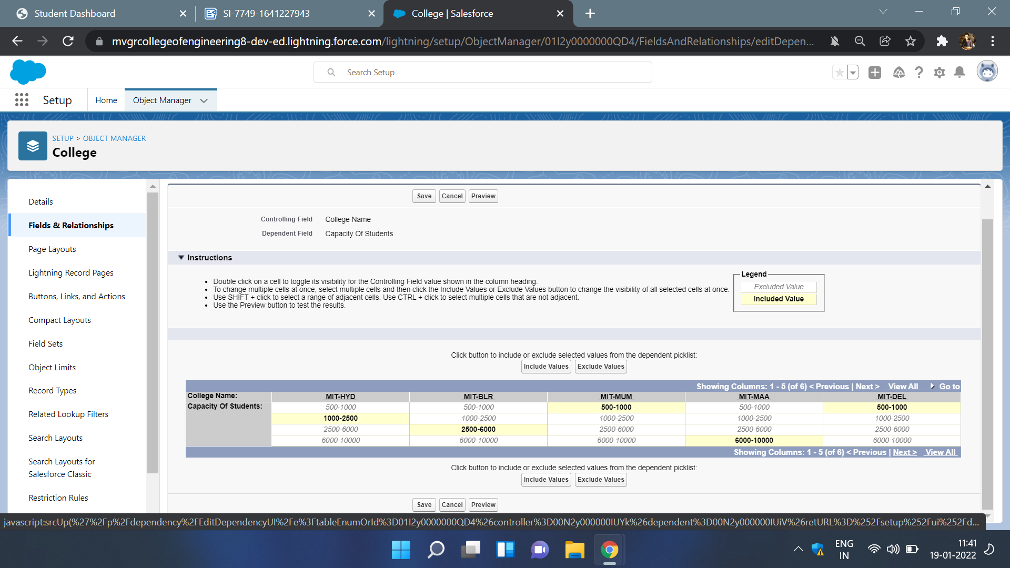

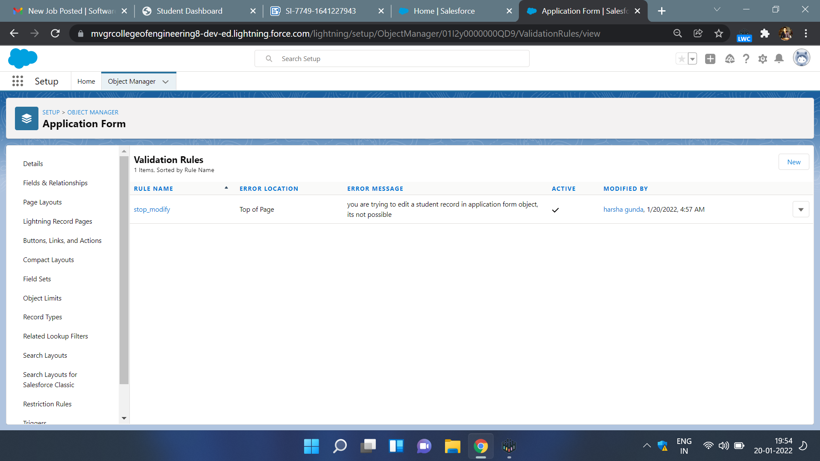

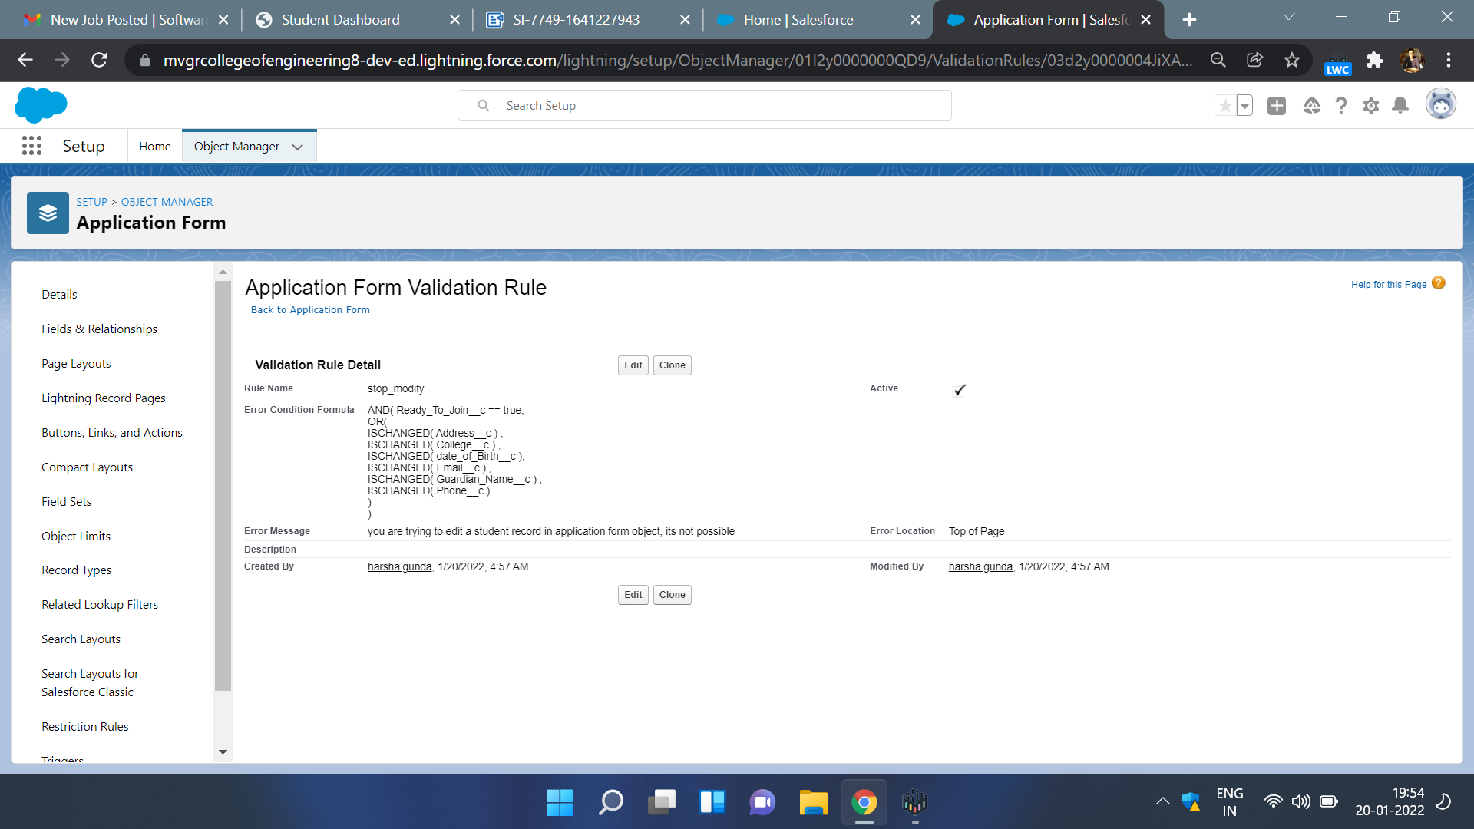

**Day 5:**

**Topic**:adding business logic to application

**Milestone / Activities**:process automation

**Detailed Description:** Process automation is the execution of certain task when the given condition becomes true.

In the application process automation is used to create a student record when the ready to join is checked.

**Screenshot the Milestone / Activities** :

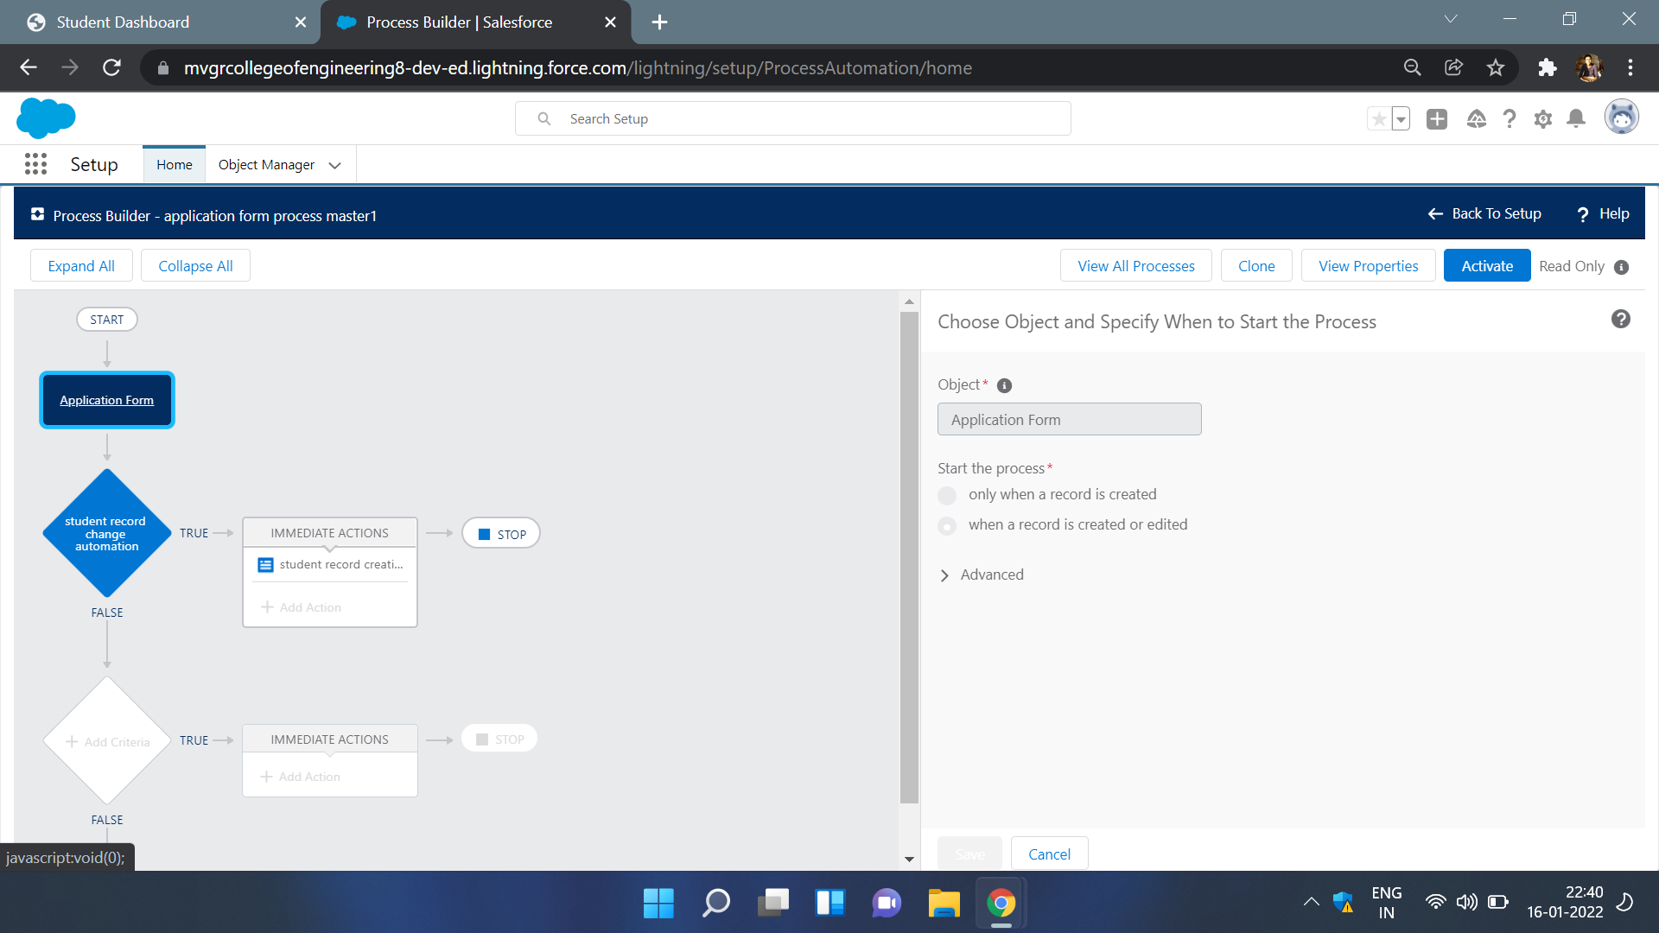

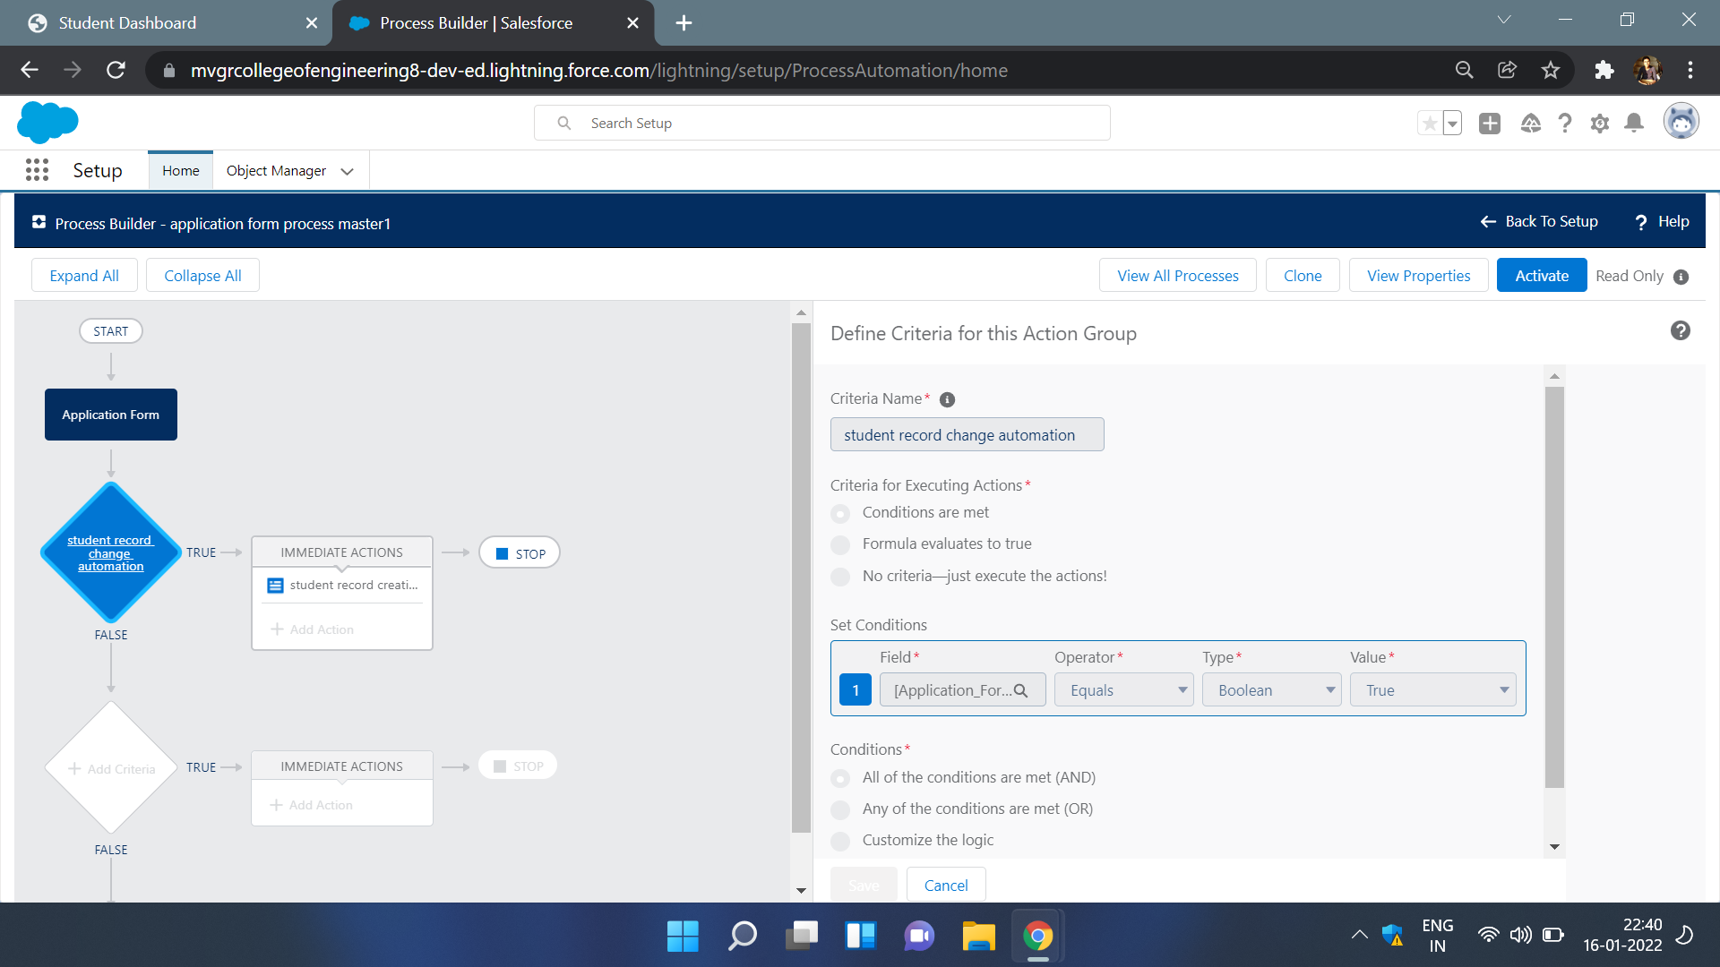

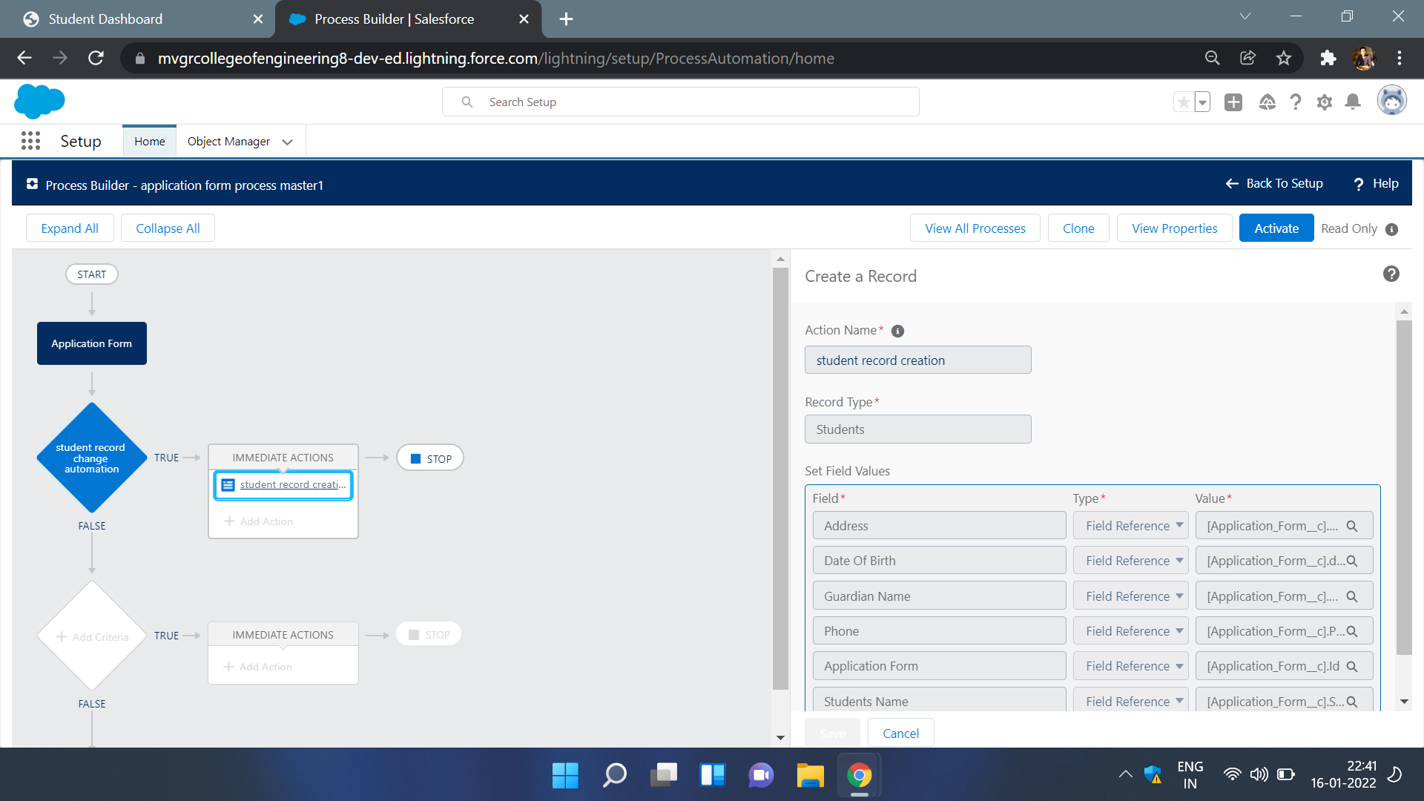

**Day 6 :**

**Topic**:Adding business logic to application

### Milestone / Activities:create the student record using flow

**Detailed Description:** flows are the special feature in salesforce that can do the works of workflow and the process builder.

In our application we use the flow to create student record when the ready to join in the application form is edited.

while creating flow we use record triggered flow,and also create a new resource of name student and assign the values of application form to student record and create records of student.

**Screenshot the Milestone / Activities** :

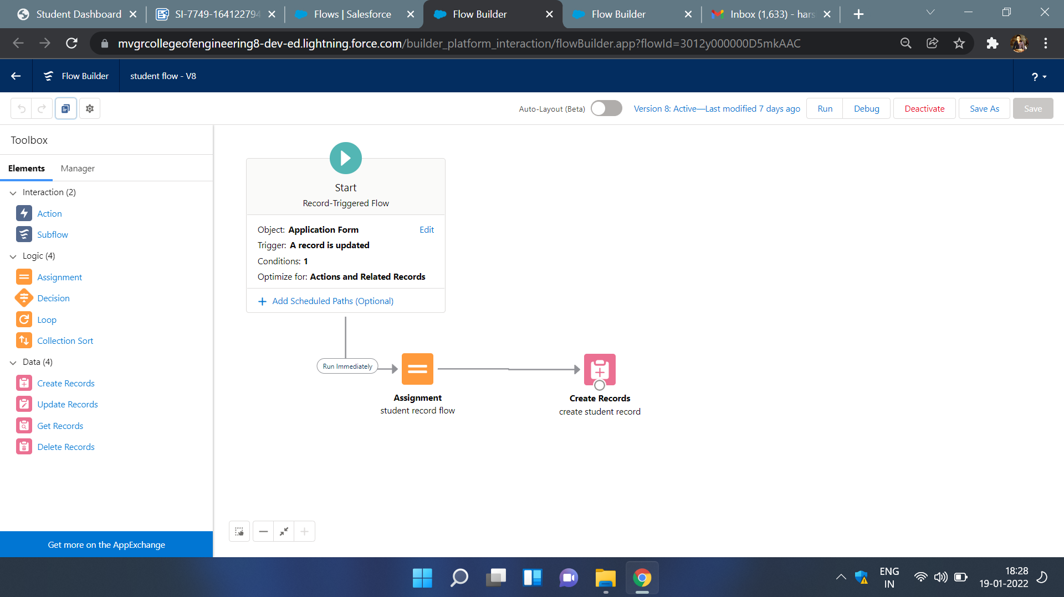

**Day 7 :**

**Topic**:Adding business logic to application

**Milestone / Activities**:create the student record using flow.

**Screenshot the Milestone / Activities** :

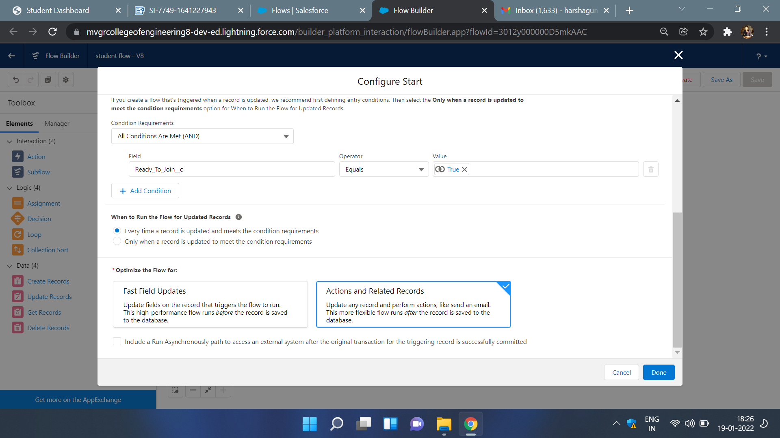

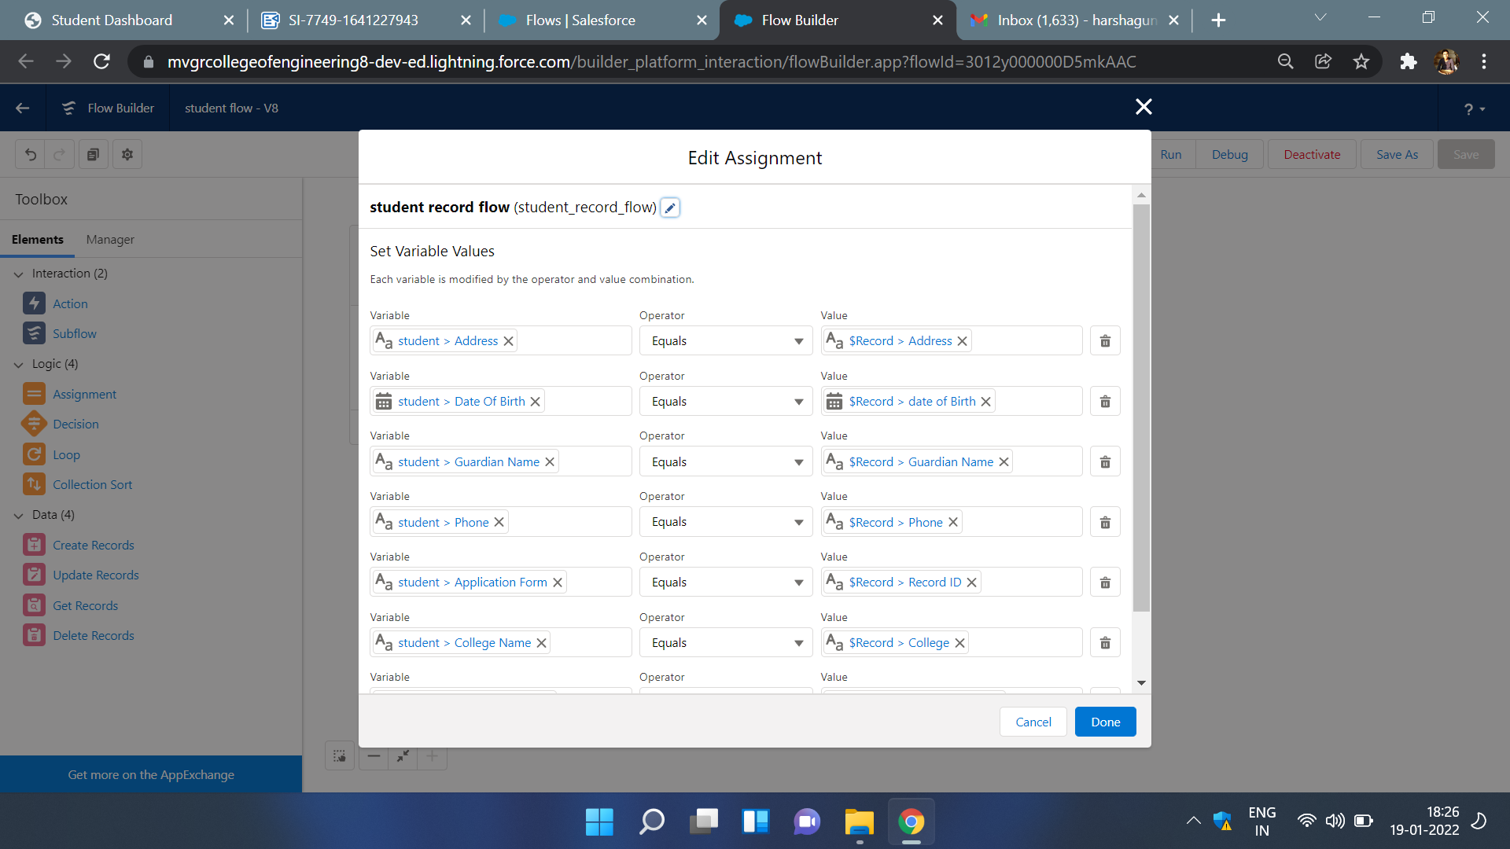

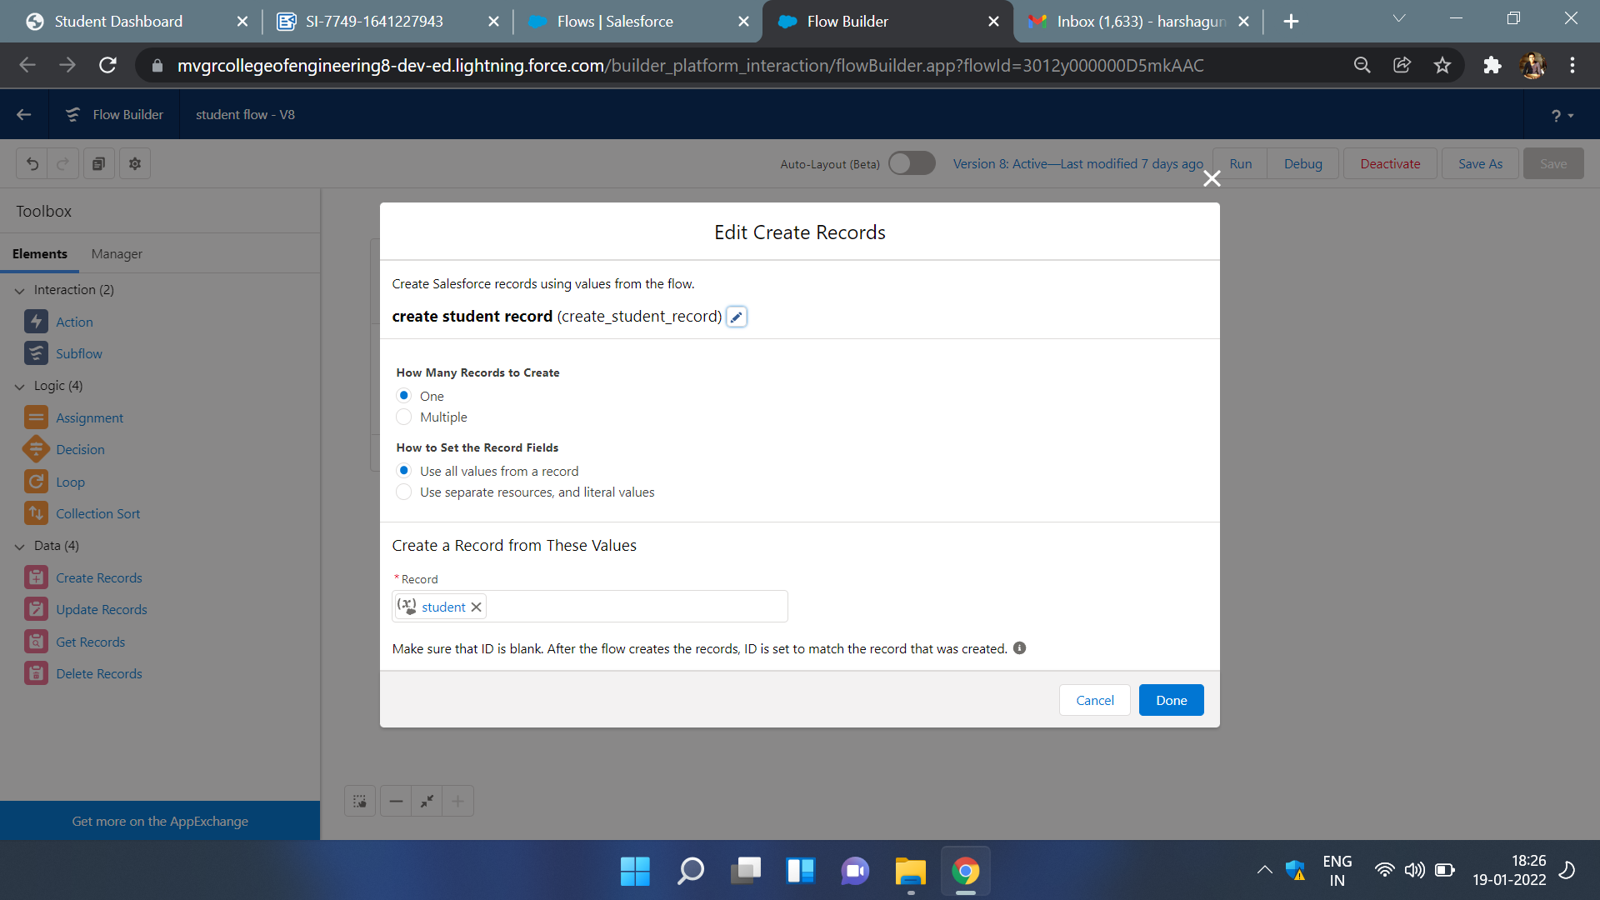

**Day 8 :**

**Topic**:Batch apex

**Milestone / Activities**:Creating batch apex for application form

**Detailed Description:** Whenever a person checks a ready to join check box then a number of students records must be incremented and at last day of the working week the manager should receive a mail that contains the total count of students willing to join.

**Screenshot the Milestone / Activities** :

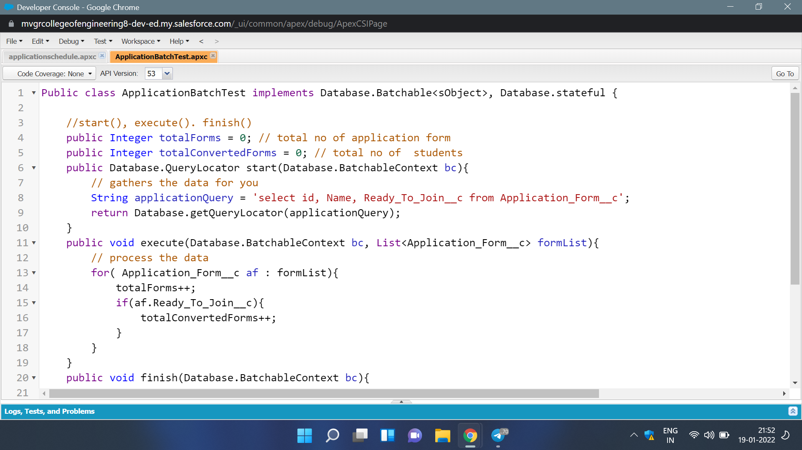

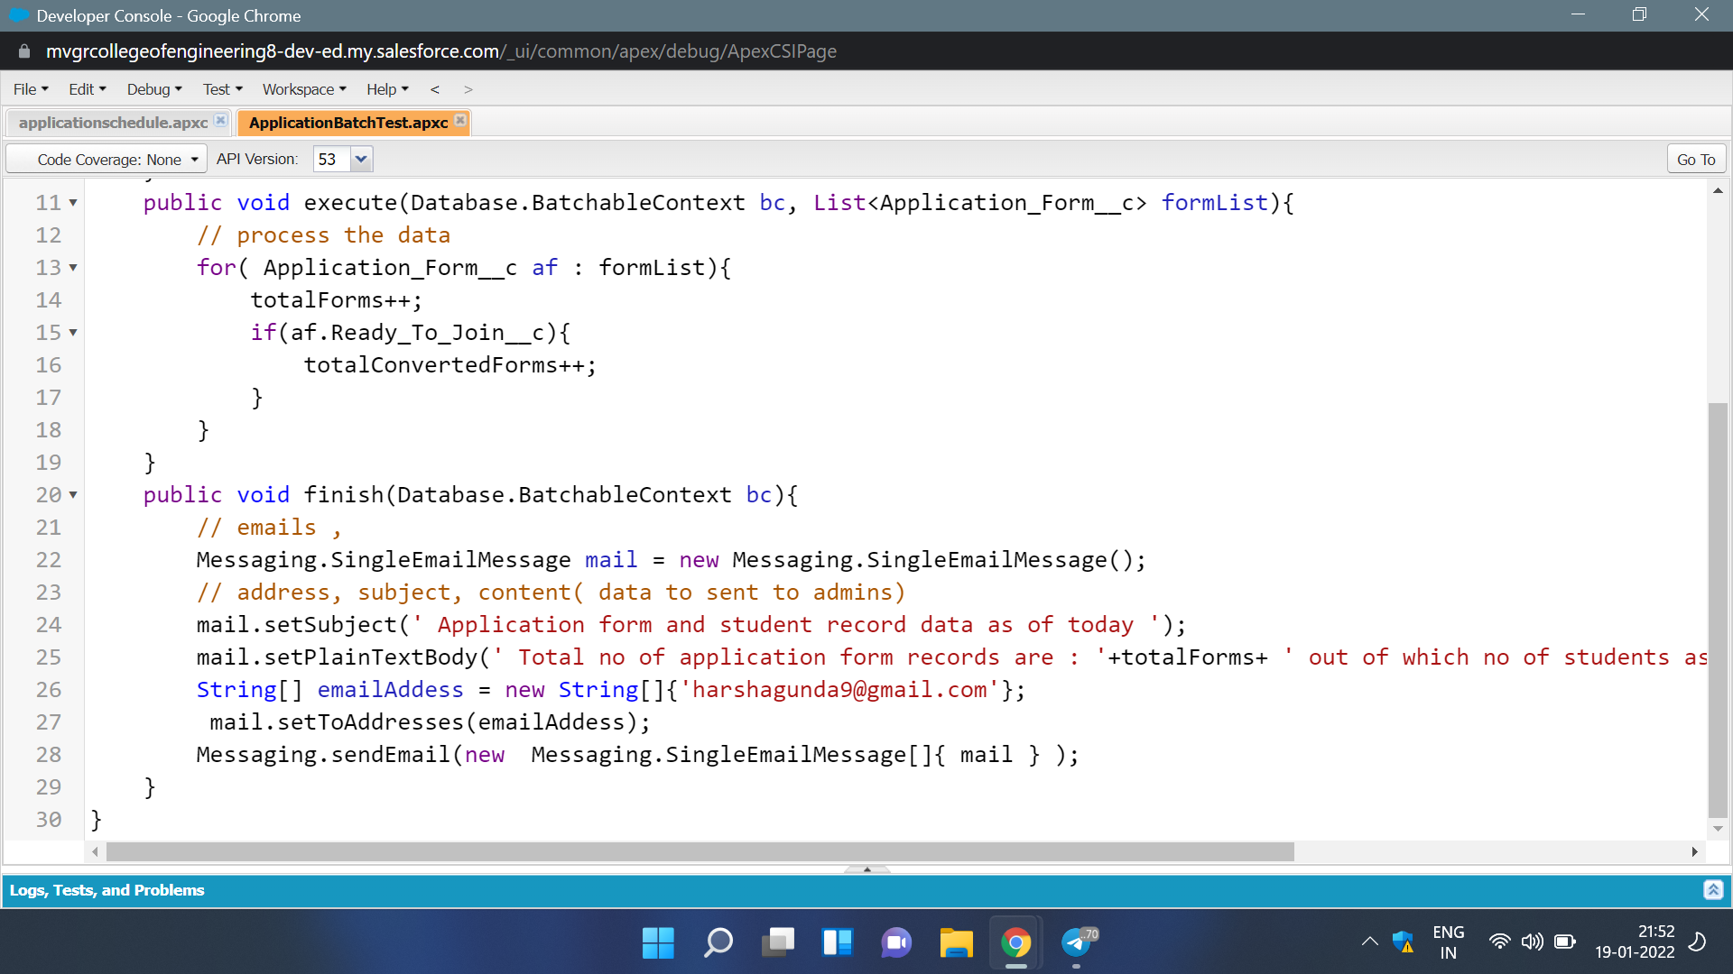

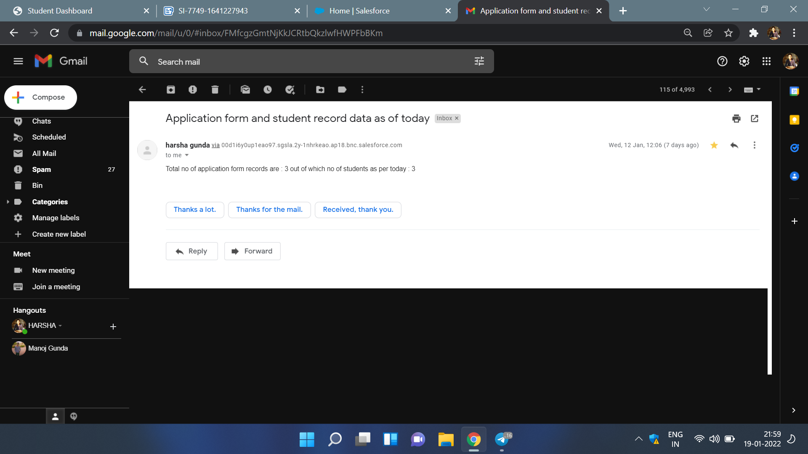

**Day 9 :**

**Topic**:Batch apex

**Milestone / Activities**:Creating a apex Scheduler class .

**Detailed Description:** Whenever a person checks a ready to join check box then a number of students records must be incremented and at last day of the working week the manager should receive a mail that contains the total count of students willing to join. By using scheduler apex we can schedule time when to trigger a mail.

**Screenshot the Milestone / Activities** :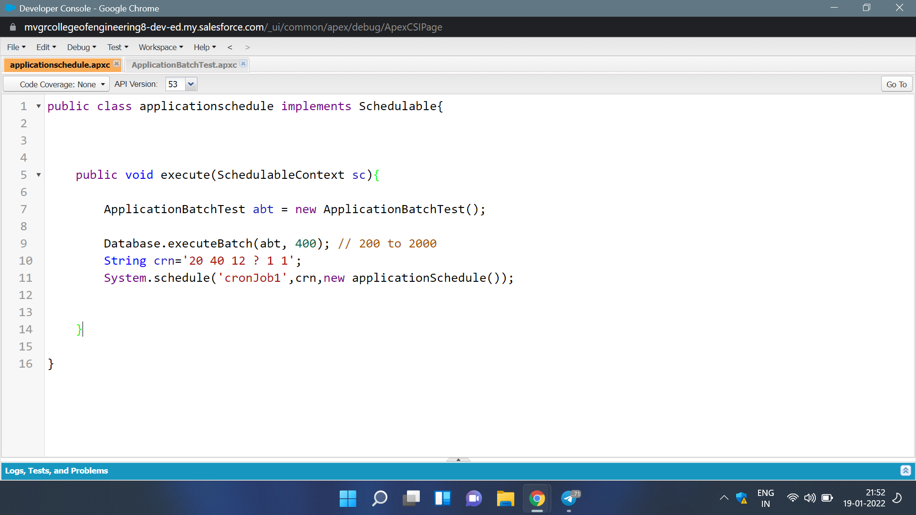



**Day 12 :**

**Topic**: Lightning Web Components

### **Milestone / Activities**:Create College DataTable Component( APEX CLASS)

**Detailed Description:** For Lightning Web Components task first we need to add Salesforce LWC editor extension to chrome and next we need to pin to chrome.

Next we need to create a apex class and write the given code and deploy it.

Next step create a component with existing apex class. Component contains a javascript file, html file, xml file .

Write the respective codes into respective files and deploy them.

Actually the task is to create a dataTable of student records of respective colleges.

**Screenshot the Milestone / Activities** :

